Houston Aggie Moms President's Endowed Scholarship Recipient 2015

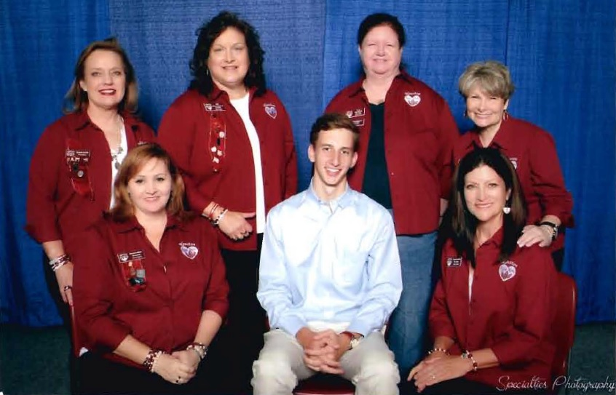
Seated: Naomi Miller, William Pfeiffer '19, Beverly Krell
Standing: Kristi Smith, Vicki Brown-Sobecki '78, Fran Marintsch, Cheryl Dinwoodie

